Training RFP - First Round of Questions

No. | Context | Question | ARM’s Response
1 | “Ensure that the System can systematically perform content management queries to ensure currency of training provider and program details on this extensive database.” | Typically Training Programs have given schedule (including expiration dates). This has not been included in the fields to be captured for the Training Program (Which I assume may get included as the we proceed if required and applicable). With this field, we can check internally first for its freshness and validity. What’s your current thought on the same. | Expiration dates are not always available, especially with degree-based programs. That said, ARM Institute prefers a system that captures expiration dates when available.
2 | Alignment of Training Programs to ARM Institute competency frameworks (Current & Future) | Has there been any plan or preferred strategy on the criteria to adapt for mapping Training Programs to Competency framework ? Also, what is the current processes and criteria adapted for the mapping? | The current process utilizes a keyword match between desired competencies and program title and description. ARM Institute is open to alternative approaches. Our goal is to have an accurate and complete list of training programs that map to the competency frameworks.
3 |  | Same question may also be extended to the scoring mechanism to understand the depth of mapping. There are mechanisms like Direct keyword/semantic match ,Bloom's taxonomy level alignment (e.g., match in cognitive depth), Coverage (how many competencies a program hits) or Gap analysis (which competencies are not covered). So any plans so far on what is followed currently and / or what is expected in the future ?
4 | National workforce web-based platform, www.roboticscareer.org | We understand that the detailed technical architecture along with the Training Provider and Program data model can be investigated once the program starts. | Please see the accompanying documents. Training Programs Data File and Specification and Architecture Diagram.
4 |  | But can we have a high-level understanding on the Cloud Infrastructure on which the web application is deployed along with the technology stack of the application?
5 | Overall Project Timelines | Are there any expectations or needs to complete the implementation of this project before a particular data/month? | ARM Institute would like phase 1 to be completed this calendar year.
6 | Dependency on ARM Institute Stakeholders | ARM SMEs guidance will be required and crucial to help build the ontology for the competency frameworks (Current and Future) along with other functional guidance including validation and UAT of the mappings done by the system. | Yes, ARM Institute will work with the selected supplier to provide guidance (both functional and with competency frameworks), in addition to user acceptance testing.  ARM anticipates a staged development environment including Development, Testing and Production.
6 | Dependency on ARM Institute Stakeholders | From the Engineering and platform standpoint what services and guidelines from ARM are we expected to use / depend on and plan till it gets rolled out to Production. For Ex DevSecOps / DevOps, Infra Provisioning for Dev/Test/Prod environment, Compliance (If applicable), Security, Enterprise architecture Review Board, Technology standards and Guidelines etc
7 | Compliance Needs | Are there any specific and already identified compliance needs which the engineering team needs to consider like SOC2, FERPA, GDPR etc for the project? If so please elaborate | RoboticsCareer is intended for a U.S. audience. Best practices around data privacy and cookie consent are expected. There is no requirement for FERPA compliance since we are not collecting education records. There is no need for SOC2 and GDPR compliance at this time.
8 | Cybersecurity Needs | Are there any expectations on performing Vulnerability assessments as well as Penetration testing as part of engineering activity? Or ARM already has a DevSecOps pipeline which we have to adhere and ARM also has 3rd Party vendors for Penetration Testing? | ARM Institute anticipates the System will be deployed behind our firewall. We expect the selected supplier will employ best practices in design and deployment to protect the System from cybersecurity threats.
9 | Contract Requirement | Is there a requirement for software development to be based within the United States? | Yes, per funding requirements, all software development, site hosting, and housing of source code must occur within the United States.
10 | Sample Output | We’re curious about the request to include "Sample Output. small sample of extracted program data" in the RFP response. Can you elaborate on what is expected? | ARM Institute is expecting a representative sample of the data collected from the proposed System. Our goal is to evaluate accuracy and completeness of the information. Please see the Sample Complete Record listed below for more details.

Training Programs Data File Specification
This document specifies the structure and required fields for data files containing training program information. It includes comprehensive definitions, allowed values, and examples for various data elements, such as provider details, program specifics, format, tuition, credentials earned, competencies, skills, and target audience demographics, structured in a JSON format.

Sample Complete Record
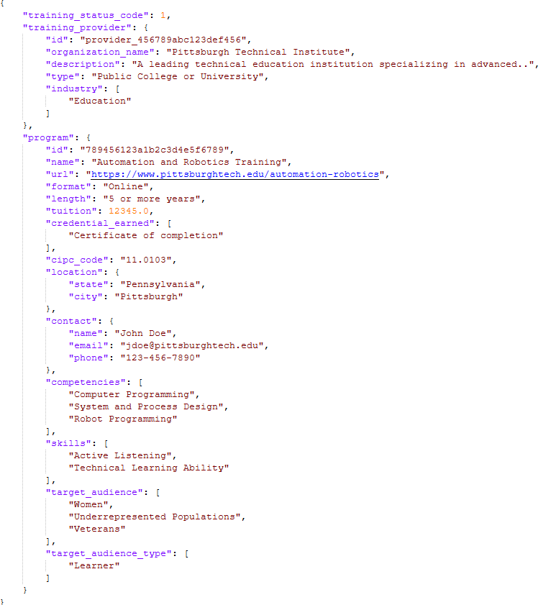
Architecture Diagram

Frontend:
- Angular 14
  - Modern, component-based JavaScript framework for building single-page web applications.
  - Delivered as a client-side SPA (Single Page Application) that runs in the user’s browser.
Backend/API:
- .NET 6 Web API
  - API built using Microsoft’s .NET 6 platform.
  - Handles business logic, authentication, and all server-side processing.
  - Deployed to Azure App Service, a managed web hosting platform in Microsoft Azure.
Database:
- Azure SQL Database
  - Fully managed relational database service.
  - Used for persistent structured data storage.
Hosting/Cloud Infrastructure:
- Microsoft Azure
  - All major components are deployed and managed within the Azure cloud environment, leveraging Azure-native services.

File Storage:
- Azure Blob Storage
  - Scalable object storage for unstructured data such as documents, images, or backups.
  - Accessed via the Azure SDK or REST API from the .NET backend.

